 | 7.1.40 Editors - 3D Viewport - Header - Armature - Pose mode - Pose menu
Table of content
Detailed Table of content 2
Pose Mode - Pose Menu 5
Transform - Submenu 5
Move (Legacy) 5
Rotate (Legacy) 5
Scale (Legacy) 5
To Sphere 6
Shear 6
Bend 6
Push/Pull 6
Clear Transform - Submenu 6
Clear Transform 6
Apply - Submenu 7
Apply Pose as Rest Pose 7
Apply Selected as Rest Pose 7
Apply Visual Transform to Pose 7
Assign Custom Property Values as Default 7
Snap - Submenu 8
Last Operator Snap 8
Animation - Submenu 8
Insert Keyframe 8
Delete Keyframes 8
Clear Keyframes 8
Change Keying Set 8
Bake Action 8
Bake Mesh to Grease Pencil 9
Bake Object Transform to Grease Pencil 9
In-Between - Submenu 9
Header values 9
Footer hotkey display 9
Push Pose from Rest Pose 9
Relax Pose to Rest Pose 10
Push Pose from Breakdown 11
Relax Pose to Breakdown 11
Blend to Neighbour 12
Propagate - Submenu 13
Last Operator Propagate Pose 14
Single Operators 14
Copy Pose 15
Paste Pose 15
Paste Pose Flipped 15
Motion Paths - Submenu 15
About Bone Collections 16
Move to Bone Collection 16
Bone Collections – Sub Menu 16
Parent - Submenu 17
Inverse Kinematics - Sub Menu 17
Constraints - Submenu 19
Names - Submenu 20
Flip Quats 21
Show/Hide - Submenu 21
Bone Settings - Submenu 21

Detailed Table of content

Detailed table of content
Detailed Table of content 2
Pose Mode - Pose Menu 5
Transform - Submenu 5
Move (Legacy) 5
Rotate (Legacy) 5
Scale (Legacy) 5
To Sphere 6
Shear 6
Bend 6
Push/Pull 6
Clear Transform - Submenu 6
Clear Transform 6
All 6
Clear User Transforms 6
Location 6
Rotation 6
Scale 7
Reset Unkeyed 7
Last Operator Clear User Transforms 7
Only Selected 7
Apply - Submenu 7
Apply Pose as Rest Pose 7
Apply Selected as Rest Pose 7
Last Operator Apply Pose as Rest Pose 7
Selected only 7
Apply Visual Transform to Pose 7
Assign Custom Property Values as Default 7
Last Operator Assign Custom Property Values as Default 7
Process data properties 7
Process bone properties 8
Snap - Submenu 8
Last Operator Snap 8
Offset 8
Animation - Submenu 8
Insert Keyframe 8
Delete Keyframes 8
Clear Keyframes 8
Change Keying Set 8
Bake Action 8
Bake Mesh to Grease Pencil 9
Bake Object Transform to Grease Pencil 9
In-Between - Submenu 9
In Between 9
Header values 9
Footer hotkey display 9
Push Pose from Rest Pose 9
Last Operator Push Pose from Rest Pose 10
Percentage 10
Previous Keyframe 10
Next Keyframe 10
Channels 10
Axis Lock 10
Relax Pose to Rest Pose 10
Last Operator Relax Pose to Rest Pose 10
Percentage 10
Previous Keyframe 10
Next Keyframe 10
Channels 10
Axis Lock 10
Push Pose from Breakdown 11
Last Operator Push Pose 11
Percentage 11
Previous Keyframe 11
Next Keyframe 11
Channels 11
Axis Lock 11
Relax Pose to Breakdown 11
Last Operator Relax Pose to Breakdown 11
Percentage 11
Previous Keyframe 11
Next Keyframe 11
Channels 12
Axis Lock 12
Pose Breakdowner 12
Last Operator Pose Breakdowner 12
Percentage 12
Previous Keyframe 12
Next Keyframe 12
Channels 12
Axis Lock 12
Blend to Neighbour 12
Last Operator Blend to Neighbour 13
Factor 13
Previous Keyframe 13
Next Keyframe 13
Channels 13
Axis Lock 13
Propagate - Submenu 13
Last Operator Propagate Pose 14
Terminate Mode 14
To Next Keyframe 14
To Last Keyframe 14
Before Frame 14
Before Last Keyframe 14
On Selected Keyframes 14
On Selected Markers 14
End Frame 14
Single Operators 14
Copy Pose 15
Paste Pose 15
Paste Pose Flipped 15
Last Operator Paste Pose 15
Flipped on X Axis 15
On Selected Only 15
Motion Paths - Submenu 15
Calculate 15
Last Operator Calculate Object Path 15
Start 15
End 15
Bake Location 15
Clear 16
Update Armature Motion Paths 16
Update All Motion Paths 16
About Bone Collections 16
Move to Bone Collection 16
New Bone Collection 16
Bone List 16
Bone Collections – Sub Menu 16
Add 17
New 17
Bone List 17
Show All 17
Assign to New 17
Last Operator add Selected Bones to Collection 17
Bone Collection 17
Parent - Submenu 17
Inverse Kinematics - Sub Menu 17
Add IK to Bone 18
Last Operator Add IK to Bone 18
With Targets 18
Remove IK 19
Constraints - Submenu 19
Add (With Targets) 19
Copy Constraints to selected Bones 19
Clear Pose Constraints 20
Names - Submenu 20
Autoname Left/Right 20
Autoname Front/Back 20
Autoname Top/Bottom 20
Last operator Autoname by Axis 20
Axis 20
Flip Names 20
Last operator Flip Names 21
Strip Numbers 21
Flip Quats 21
Show/Hide - Submenu 21
Show Hidden 21
Hide Selected 21
Hide Unselected 21
Bone Settings - Submenu 21
Last Operator Collection Boolean Set 22

Pose Mode - Pose Menu
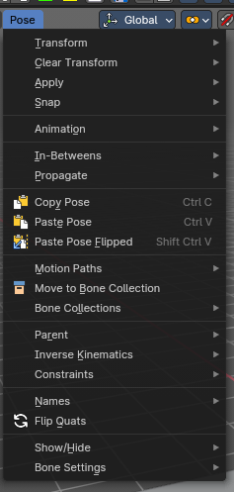
The Pose menu contains the tools to work with Armature objects in Pose mode. This means here you find all the tools that you need to pose and animate your armature.

Transform - Submenu

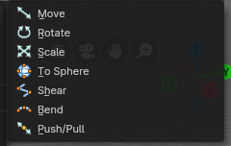
This submenu contains transform operators to help
pose a selection of bones. For more information, refer to the transform operators in the 3D Viewport - Header - Armature - Edit mode - Armature menu chapter

Move (Legacy)
A legacy transform operation where you activate once then click to apply. This is useful in Weight Painting mode to pose an armature while painting weights.

Rotate (Legacy)
A legacy rotate operation where you activate once then click to apply. This is useful in Weight Painting mode to pose an armature while painting weights.

Scale (Legacy)
A legacy scale operation where you activate once then click to apply. This is useful in Weight Painting mode to pose an armature while painting weights.

To Sphere
Shapes a selection of bones into the shape of a sphere. This tools requires to have more than one bone selected.

Shear
Shear shears the selection. This tools requires to have more than one bone selected.

Bend
Bends the selection. This tools requires to have more than one bone selected.

Push/Pull
It pushes or pulls the bone positions relative to the center of the selection. This tools requires to have more than one bone selected.

Clear Transform - Submenu

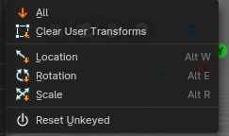
Clear Transform
Clear transform is a menu with some Clear functionality. You need to have the bones selected where you want to perform the operation. Unselected bones will not be calculated.

All
Resets location, rotation and scale back to the Rest pose.

Clear User Transforms
Resets Pose of selected bones back to keyframe state.

Location
Resets location back to the Rest pose.

Rotation
Resets rotation back to the Rest pose.

Scale
Resets scale back to the Rest pose.

Reset Unkeyed
Resets the pose for the selected bones back to the state of the latest keyframe.

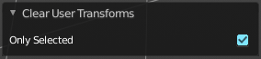
Last Operator Clear User Transforms

Only Selected
Clear User transform for selected armature part, or for the whole armature.

Apply - Submenu
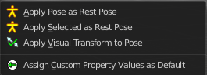
Apply is a menu with some Apply functionality.

Apply Pose as Rest Pose
You need a rest pose where you can reset the pose back to. With this tool you can set the current pose to be the new Rest pose.

Apply Selected as Rest Pose
You need a rest pose where you can reset the pose back to. With this tool you can set the current pose of the selected bones to be the new Rest pose.

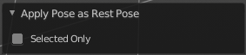
Last Operator Apply Pose as Rest Pose

Selected only
Just apply the pose to the selected part.

Apply Visual Transform to Pose
Apply final constrained position of posed bones to their transform.

Assign Custom Property Values as Default
Assigns the current values of custom properties as their defaults. This allows to use them as part of the rest pose state in NLA track mixing.

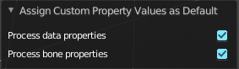
Last Operator Assign Custom Property Values as Default

Process data properties
Include the process data properties.

Process bone properties
Include the process bone properties.

Snap - Submenu

Choose several methods to snap one element to another. The menu items should be self explaining.

Last Operator Snap

Some snap operations shows a last operation panel, some not.

Offset
If the selection should snap as a whole, or if each individual element of the selection should snap.

Animation - Submenu
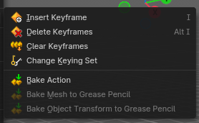
Animation is a sub menu around animation functionality. You need to have an object in the scene.

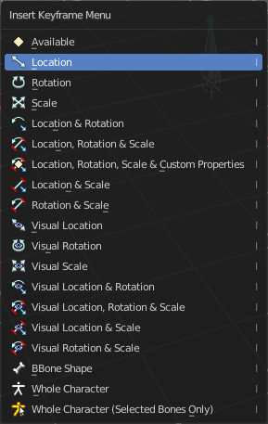
Insert Keyframe
Opens a menu where you can insert a keyframe with a defined keying set.

Delete Keyframes
Deletes keyframes at the current frame.

Clear Keyframes
Deletes all keyframes.

Change Keying Set
Opens a menu where you can change the keying set. It is basically the same than the insert keyframe menu.

Bake Action
Bake all selected objects location/scale/rotation animation to an action.

Bake Mesh to Grease Pencil
Only works on Mesh objects

Bake Object Transform to Grease Pencil
Only works on Mesh objects

In-Between - Submenu

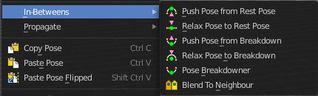
In Between
In Between are tools to influence the look of the pose between the keyframes.
For example, record a keyframe at frame 1, then record a keyframe at frame 20. Then go to frame 10, and activate one of the tools. Now you can play around with the settings. And when you are satisfied with the result then you can record a keyframe at this position.

Header values
When you activate one of the tools, then you will see a percentage slider in the header. This slider is not interactive. It just displays the percentage of the exaggeration.

Footer hotkey display
In the footer you will some hotkeys for further options. This hotkeys are hard coded, and cannot be changed in the input manager.

The hotkeys W, E and R stands for the usual transform modes move, rotate or scale. Hotkey B stands for Bendy Bones. And C is for a custom property.
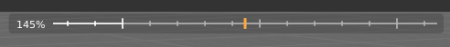
Overshoot allows you to go over the 0 -100 per cent range. The header values shows a bigger range then.
The rest of the hotkeys should be self explaining.

Push Pose from Rest Pose
Exaggerates the current pose. Pushes the current pose further away from the rest pose.

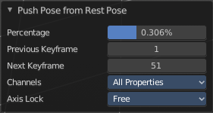
Last Operator Push Pose from Rest Pose

Percentage
The percentage of exaggeration.

Previous Keyframe
The keyframe position before the current frame.

Next Keyframe
The keyframe position after the current frame.

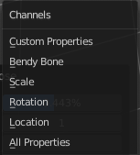
Channels
Limit the push effect to specific channels.

Axis Lock
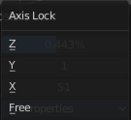
Limit the push effect to specific axis.

Relax Pose to Rest Pose
Relaxes the current pose towards the Rest pose.

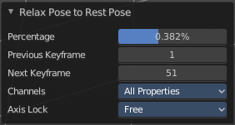
Last Operator Relax Pose to Rest Pose

Percentage
The percentage of relaxing.

Previous Keyframe
The keyframe position before the current frame.

Next Keyframe
The keyframe position after the current frame.

Channels
Limit the relax effect to specific channels.

Axis Lock
Limit the relax effect to specific axis.

Push Pose from Breakdown
Exaggerates the current pose. Pushes the current pose further away from the previous pose.

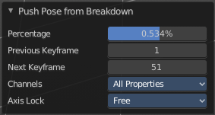
Last Operator Push Pose

Percentage
The percentage of exaggeration.

Previous Keyframe
The keyframe position before the current frame.

Next Keyframe
The keyframe position after the current frame.

Channels
Limit the push effect to specific channels.

Axis Lock
Limit the push effect to specific axis.

Relax Pose to Breakdown
Relaxes the current pose.

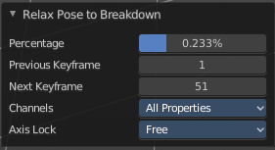
Last Operator Relax Pose to Breakdown

Percentage
The percentage of relaxing.

Previous Keyframe
The keyframe position before the current frame.

Next Keyframe
The keyframe position after the current frame.

Channels
Limit the relax effect to specific channels.

Axis Lock
Limit the relax effect to specific axis.

Pose Breakdowner
Creates a suitable breakdowner pose on the current frame.

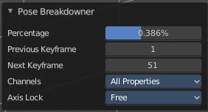
Last Operator Pose Breakdowner

Percentage
The percentage of exaggeration.

Previous Keyframe
The keyframe position before the current frame.

Next Keyframe
The keyframe position after the current frame.

Channels
Limit the breakdowner pose to specific channels.

Axis Lock
Limit the breakdowner pose to specific axis.

Blend to Neighbour
Blends the current pose with the neighbouring poses.
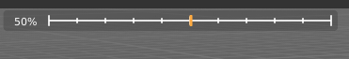
When you perform the tool then you will see a per cent slider in the header where you can read the percentual influence of the blending. Move the mouse to position the blend pose where you need it.

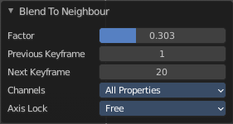
Last Operator Blend to Neighbour

Factor
The blend factor.

Previous Keyframe
The keyframe to calculate from before the current position.

Next Keyframe
The keyframe to calculate from after the current position.

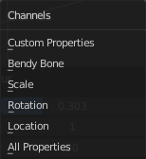
Channels

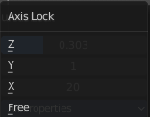
Axis Lock
Lock the transformation along an axis.

Propagate - Submenu
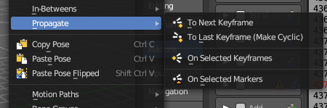
The Propagate tool automates the process of copying and pasting between keyframes. It copies the pose of the selected bones on the current frame over to the keyframes by the chosen Termination mode in the Last Operator Propagate Pose.
The different Propagate methods can be adjusted in the Last operator too. Here you will find even more methods. The menu just lists the common ones.
The methods are quite self explaining, but are explained in the last operator section.

Usage example with Termination mode "On Selected Keyframes".
- Create a little armature.
- Set a keyframe at frame 0.
- Set a keyframe at frame 20.
- Pose frame 20.
- Set a keyframe at frame 40. It will most probably be identical with Frame 20.
- Now select those Keyframes at position 40 in the Dope Sheet Editor.
- Set position to Frame 0.
- Press Propagate, and in the Last operator Propagate Pose choose On Selected Keyframes.
The selected keyframes at frame 40 will now turn into the corresponding keyframes from position 0.

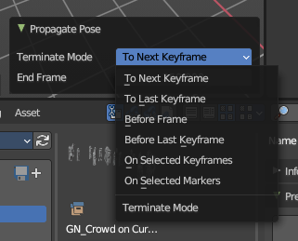
Last Operator Propagate Pose

Terminate Mode
A drop down box where you can choose between different termination modes for Propagate.

To Next Keyframe
Copies the pose to the first keyframe after the current frame.

To Last Keyframe
Replaces the last keyframe.

Before Frame
Copies to all keyframes between current frame and the End frame option.

Before Last Keyframe
To all keyframes from current frame until no more are found.

On Selected Keyframes
Applies the pose of the selected bones to all selected keyframes.

On Selected Markers
Copies to all keyframes on frames with Scene Markers after the current frame.

End Frame
Defines the end frame for the Propagate.

Single Operators

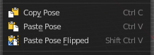
Copy Pose
Copies the current pose. You copy what you have selected.

Paste Pose
Pastes a previous copied pose.

Paste Pose Flipped
Pastes a previous copied pose, but flipped along X axis.

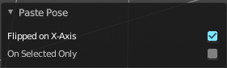
Last Operator Paste Pose

Flipped on X Axis
Paste the pose flipped along X Axis.

On Selected Only
Paste just on the selected bones. Not on the unselected.

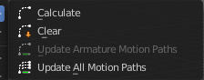
Motion Paths - Submenu

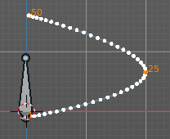
Objects can be animated. Let's say you send them from a to b to c. The object will move to b, then to c. Some kind of a path. This path is not visible by default.
With motion paths you can calculate this path, and make it visible.

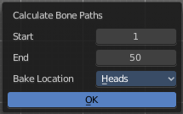
Calculate
Calculates the motion path of the selected bones. It opens a panel to define the start and end frame of the calculation.

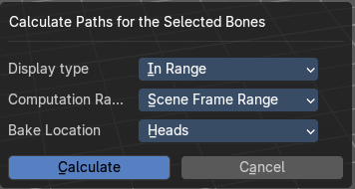
Calculate Motion path calls a setup dialog.

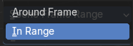
Display Type
How to display the motion path.

Around Frame
Display paths of poses within a fixed number of frames around the current frame.

In Range
Display paths of poses within specified frames.

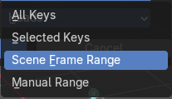
Computation Range
How much frames to compute.

All Keys
From the first keyframe to the last.

Selected Keys
From the first selected keyframe to the last.

Scene Frame Range
The entire scene / preview range.

Manual Range
Manually determined frame range.

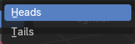
Bake Location
To bake from where.

Heads
Calculate bone paths from heads.

Tails
Calculate bone paths from tails.

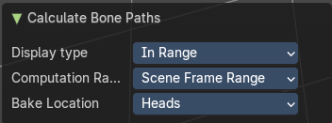
Last Operator Calculate Bone Paths
Same than the dialog.

Clear
Clear remove the motion path from the object.

Update Armature Motion Paths
Updates the motion paths of the armature.

Update All Motion Paths
Updates the motion paths of all objects.

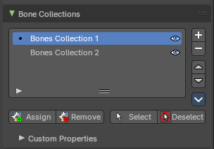
About Bone Collections
Bone Collections is a menu to handle bone collection functionality from within a menu in the 3D View editor. The bone collections themselves can be found in the Properties editor then in the Armature tab.

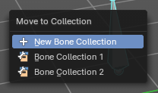
Move to Bone Collection
Armature and bones have their own collection system. This menu item opens a popup where you can put the selected bones into a New Collection or an existing Bone Collection.

New Bone Collection
Assigns the selected bones to a new Bone Collection. This will prompt to name the new collection.

Bone List
Assigns or unassigns the selected bones to or from the collection. The green + icon and red – icon show if you can remove or add a bone to the listed collection.

Bone Collections – Sub Menu
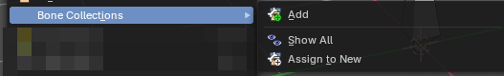
Armature and bones has its own collection system.

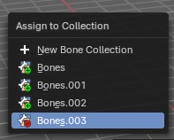
Add
Add or remove the bone from the listed bone collections. The green + icon and red – icon show if you can remove or add a bone to the listed collection. A bone can be in multiple collections at the same time.

New
Assigns the selected bones to a new Bone Collection. This will prompt to name the new collection.

Bone List
Assigns or unassigns the selected bones to or from the collection. The green + icon and red – icon show if you can remove or add a bone to the listed collection.

Show All
Show all bone collections.

Assign to New
Add selected bones to a new collection with a new name.

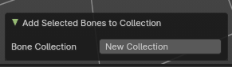
Last Operator add Selected Bones to Collection

Bone Collection
Change name of the new collection.

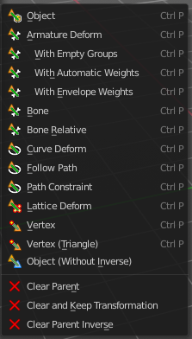
Parent - Submenu
Parenting the skin or other armatures happens in Object mode. You can also parent in Pose Mode. It just does not make much sense since you need to enter Object mode for one of the objects anyways. The only somehow relevant settings in the parenting menu here is clear parent. But even this is better done in Object Mode.
The parenting menu is already explained in the Object menu in Object mode. So we won't repeat the whole description here.

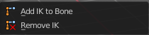
Inverse Kinematics - Sub Menu
Inverse Kinematics is a menu with two isolated items from the whole bone constraints menu. The Inverse Kinematics. You could also add an Inverse Kinematics bone constraint by the Constraints / Add (With Targets) menu item from above. It is in the list. But this menu allows quick access without big search.

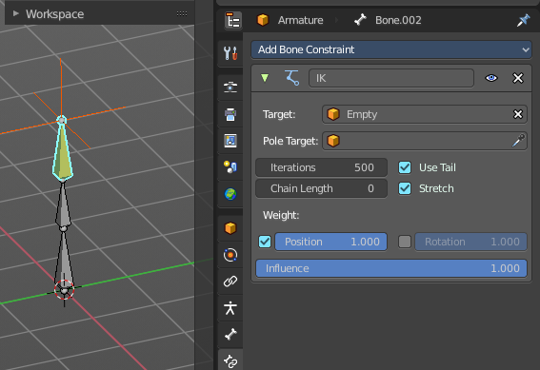
Add IK to Bone
Add IK to bone adds an IK bone constraint to the selected bone. When you add an IK constraints with just the bone selected, then it adds an empty as a handler too, and fills it in as a target.
Add IK calls a popup. When you have just one bone selected then you can choose between adding an empty as the target or to create the bone constraint without target.
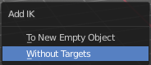
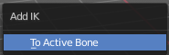
When you have more than one bone selected then you can just add the constraint to the active bone.

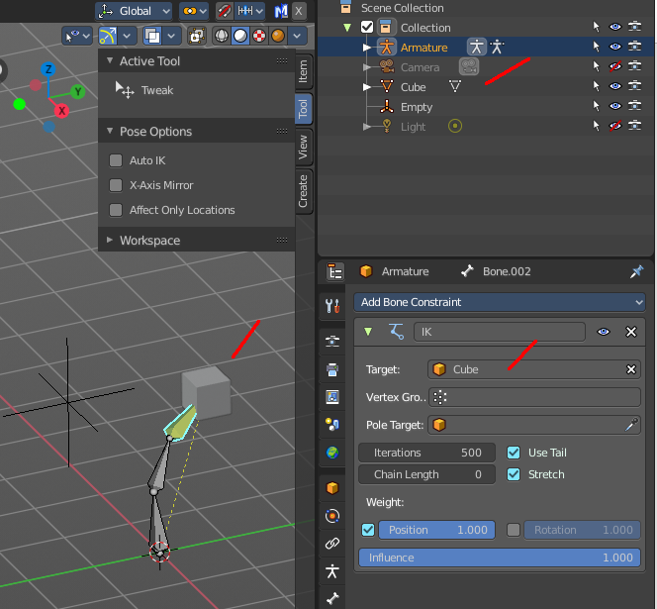
You can define an own target object too. The armature needs to be in pose mode. Let's create a cube or another primitive. Select it. Now hold down Shift, and click at the bone where you want to add the constraint too. Then choose Add (with Targets), and choose your constraint method. The cube will now be chosen as the target object.

Last Operator Add IK to Bone

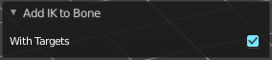
With Targets
Define if you want to add the IK constraints with or without a target.

Remove IK
Removes all IK bone constraint(s) at the selected bone(s).

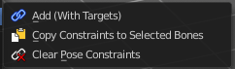
Constraints - Submenu
Constraints is a menu that contains some tools around constraints.

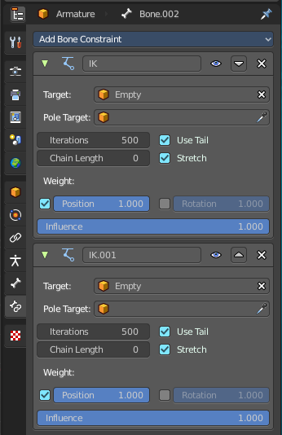
Add (With Targets)
Add (With Targets) calls the Constraints menu where you can choose the constraint that you want to add. When you add an IK constraints with just the bone selected, then it adds an empty as a handler too, and fills it in as a target. Which is similar to what you can do with the Add IK to Bone from the IK menu.

But you can add more than just the IK constraint. It is the same menu that you can open by clicking at the Add Bone Constraint drop down menu in the Properties editor.

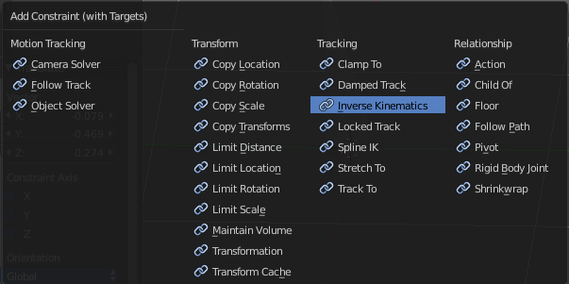

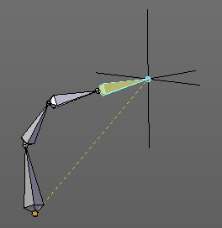

You can define an own target object too. The armature needs to be in pose mode. Let's create a cube or another primitive. Select it. Now hold down Shift, and click at the bone where you want to add the constraint too. Then choose Add (with Targets), and choose your constraint method. The cube will now be chosen as the target object.

Copy Constraints to selected Bones
Copies the constraints with all its settings to the selected bone.
Usage:
Select the bone where you want to copy the constraints to. Hold down shift, then select the bone that contains the constraints. Then perform the tool. The constraints will be copied.

Clear Pose Constraints
Removes all bone constraints modifiers from the bone.

Names - Submenu
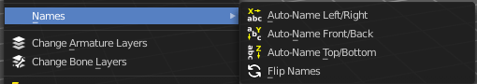
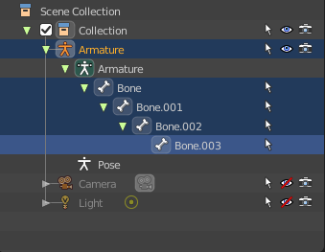
Bforartists has some internal name conventions for a symmetrical armature. Bones are for example named mybone.L or mybone.R, dependant at which side of the mirror axis they are. The Names items allows you to rename the bone names to this name convention.

Autoname Left/Right
Renames the bones from left to right.

Autoname Front/Back
Renames the bones from front to back.

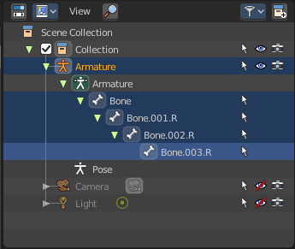
Autoname Top/Bottom
Renames the bones from top to bottom.

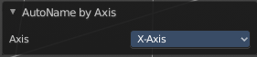
Last operator Autoname by Axis

Axis
Choose the autoname axis again. Left/Right is X axis, Front/Back is Y axis, and Top/Bottom is Z axis.

Flip Names
When you mirror a half of an armature you end in names like Bone.001.R.001. But what we need is Bone.001.L for a symmetrical armature. Flip names flips the names to follow the left right name conventions.

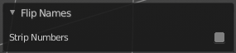
Last operator Flip Names

Strip Numbers
Tries to remove the numbers in the names if possible.

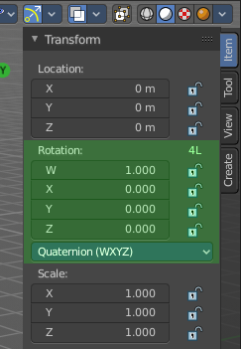
Flip Quats
This feature flips the quaternion rotation values of the currently selected bone(s). Positive values becomes negative, and negative values becomes positive.

Show/Hide - Submenu
Show or hide the selected geometry

Show Hidden
Makes all hidden geometry visible again.

Hide Selected
Hides the selected geometry.

Hide Unselected
Hides the not selected geometry. The selected geometry stays visible.

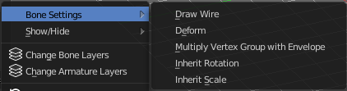
Bone Settings - Submenu
Bone Settings is a menu with menu items to toggle special check boxes in the Properties editor. But here you can do it for a selection too, and not just one object.

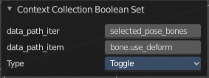
Last Operator Collection Boolean Set
Each of the menu items uses the same Last Operator. With different strings for the booleans.

